Introduction

|  |  |
| --- | --- |
| school management system  One tool for all your school activities | shruthi sathisha  Shruthi.sathisha@my.unt.edu  rameez shaik  Rameez.shaik@my.unt.edu |

School Management System is a complete school information management solution. This is a multi-user application and this database application is made for: Administrator, Faculty and Student of the school.

School Administrator as user:

Application allows an admin to add or update student information to the system, add or update faculty information to the system, add or update the courses thought in the school, add or update a classroom detail and allow users to reserve a class room, add or modify faculty pay detail, make an announcement, check concerns or feedback from a student or faculty and get a complete report on a particular student or faculty.

Faculty as user:

Application allows a faculty to take student attendance, publish an assignment, schedule an exam, view or grade an assignment, view pay information, reserve a classroom, submit concerns to the school admin if any, view and download the course materials.

Student as user:

Application allows student to views courses he is registered in, view or submit an assignment , view grades, view fee dues if any , submit a concern to school administrator if any, view or download the course materials.

User requirements

The application is password protected one must enter username and password to use the application. If a user logs in as an admin he is redirected to admin’s main page, if he is logged in as user application is redirected to student’s main page likewise for faculty it is redirected to faculty main page.

An admin should be able to add, edit and delete student information to the system. The database should auto refresh on performing above activities and admin should be able to see the changes. Likewise he should be able to add and modify faculty information, course information, class room information. An admin also enters faculty payment details, he should see a list of faculties working in the school and he can add payment to them. Admin can also make announcements for students and faculties and it reflects in faculty and student login. Admin should be able to view concerns from his students and faculties so that he can fix them. Admin should be able to generate report on student including student personal information, courses student enrolled in, and his grades. A report on faculty personal information, courses he/she is teaching and their payment information. A report on list of all courses in the department etc.

A faculty should be able view a list of students he is teaching and take attendance, publish an assignment, schedule an exam, view assignments student has submitted and grade them, view his grades, reserve a class room, submit concern to school admin if any, view or download course materials

A student should be able to view list of courses he is enrolled in, view the list of assignments he is supposed to work on and submit an assignment, view his/ her grade, view his/her fee dues and deadlines, submit concerns to school admin if any, view or download course textbooks.

Software & Language

* Microsoft Access 2013
* Visual Basics for Application (VBA)

Major entities and its description

STUDENT :

This table stores a student’s personal data like STUDENT_ID, FNAME, LNAME, DATE_OF_BIRTH,MAJOR, GENDER, ADDRESS, PHONE etc… STUDENT_ID is primary key.

FACULTY :

This table stores a faculty’s personal data like FACULTY_ID, FNAME, LNAME, PHONE, EMAIL, ADDRESS,DEPT etc.. FACYLTY_ID is primary key.

COURSE :

This table stores detail of courses school offers like COURSE_ID, TITLE , DESCRIPTION, DEPARTMENT, FEE etc.. COURSE_ID is primary key

CLASSROOM :

This table stores the class room information in the school and are they are booked by anyone or free like ROOM_NUM, CAPACITY,AVAILABLE, FROM , TO etc..

EXAM :

This table stores information on exams held and upcoming exams in school like EXAM_ID , COURSE_ID, INSTRUCTOR, EXAM_DATE, MAX_POINT etc.. EXAM_ID is primary key

ASSIGNMENTS:

This table stores assignment published by faculties and the assignment file like ASSGN_ID, PUBLISH_DATE, DUE_DATE, FACULTY_ID , FILE etc..

LOGIN :

This stores the login credentials for the users like, USERNAME, PASSWORD etc.. USERNAME is Primary key

STU_ENROLMENT :

This table stores detail of courses student enrolled in and the fee details like STUDENT_ID, COURSE_ID ENROLMENT_DATE, FEE, DUE_DATE etc..

BUSINESS RULES

* One user can have only one login credentials.
* One student can enroll to many courses.
* One course can have many students.
* One student can post many feedback.
* Feedback can have post from many students.
* One student can take many exams.
* One exam can have many students
* One faculty can have many students
* One student can be under many faculties
* One faculty can belong to one department
* One department can have many faculties
* One department can have many courses.
* One course should be from one department.
* One faculty can post many assignments
* One assignment should be posted by one faculty.
* One student can submit many assignments.
* One assignment should be submitted by only one student.
* One faculty can receive many pay.
* One pay should go to only one faculty.
* One course can have many course material
* One course material can belong to only one course.
* Faculty can book any number of classrooms if available.
* Admin can make many announcement
* Faculty can schedule many exams.
* One exam should be scheduled by only one faculty.
* One faculty can submit many feedback/concerns.
* One feedback should be submitted by only one faculty.
* Faculty can take attendance for many student under him/her.

Entity relationship diagram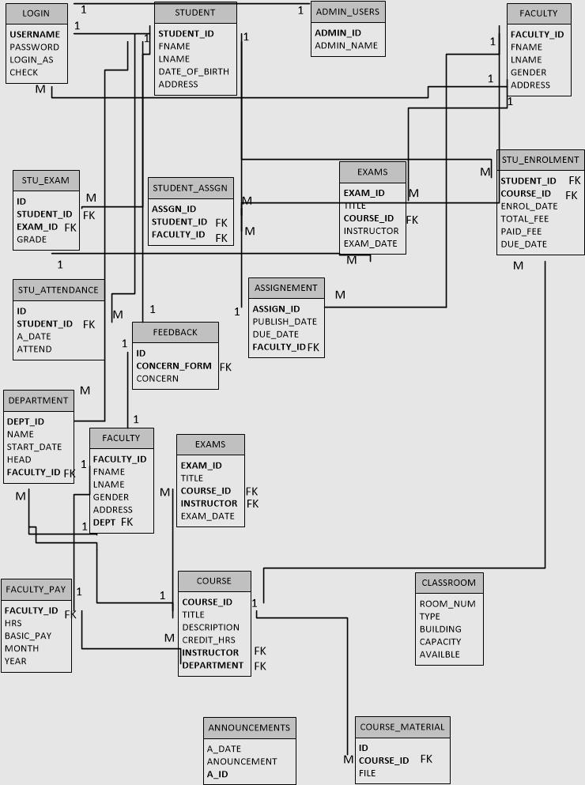

Data Dictionary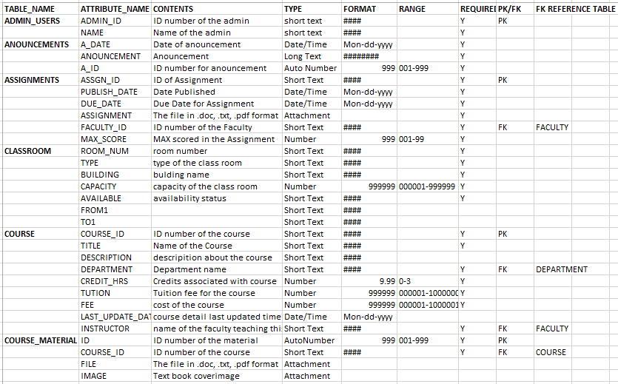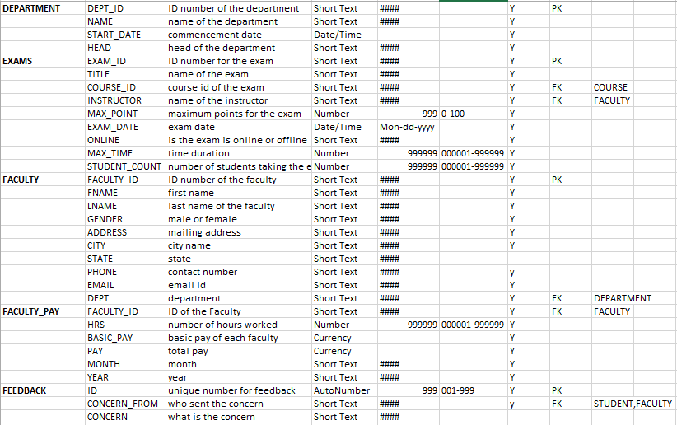

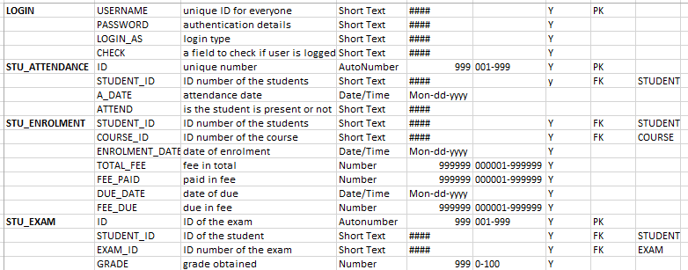

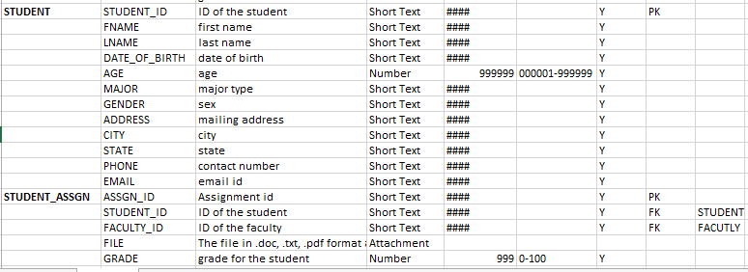

**Sample Queries**

1. To check available classrooms-

SELECT CLASSROOM.* FROM CLASSROOM WHERE (((CLASSROOM.AVAILABLE)="yes"));

1. To list all concerns from faculties-

SELECT FACULTY.FACULTY_ID, FACULTY.FNAME, FACULTY.LNAME, Feedback.Concern, Feedback.Concern_from FROM FACULTY, Feedback WHERE (((Feedback.Concern_from)=[FACULTY]![FACULTY_ID]));

1. To show faculty personal, pay and course detail -

SELECT FACULTY.*, COURSE.TITLE, FACULTY_PAY.* FROM FACULTY_PAY INNER JOIN (FACULTY INNER JOIN COURSE ON FACULTY.FACULTY_ID = COURSE.INSTRUCTOR) ON (FACULTY.FACULTY_ID = FACULTY_PAY.FACULTY_ID) AND (FACULTY_PAY.FACULTY_ID = COURSE.INSTRUCTOR) WHERE (((FACULTY.FACULTY_ID)=[Forms]![Reports_Form]![faculty_id]));

1. To show fee due of a student

SELECT COURSE.TITLE, COURSE.TUTION, COURSE.FEE, STU_ENROLMENT.TOTAL_FEE, STU_ENROLMENT.FEE_PAID, STU_ENROLMENT.FEE_DUE, STU_ENROLMENT.DUE_DATE FROM COURSE INNER JOIN (STU_ENROLMENT INNER JOIN LOGIN ON STU_ENROLMENT.STUDENT_ID = LOGIN.USERNAME) ON COURSE.COURSE_ID = STU_ENROLMENT.COURSE_ID GROUP BY COURSE.TITLE, COURSE.TUTION, COURSE.FEE, STU_ENROLMENT.TOTAL_FEE, STU_ENROLMENT.FEE_PAID, STU_ENROLMENT.FEE_DUE, STU_ENROLMENT.DUE_DATE, [LOGIN]![check] HAVING (((STU_ENROLMENT.FEE_DUE)>0) AND (([LOGIN]![check])="yes"));

1. To show list of assignment a student supposed to do

SELECT ASSIGNMENTS.ASSGN_ID, ASSIGNMENTS.PUBLISH_DATE, ASSIGNMENTS.DUE_DATE, ASSIGNMENTS.ASSIGNMENT, ASSIGNMENTS.FACULTY_ID FROM ASSIGNMENTS INNER JOIN (LOGIN INNER JOIN (COURSE INNER JOIN STU_ENROLMENT ON (STU_ENROLMENT.COURSE_ID = COURSE.COURSE_ID) AND (COURSE.COURSE_ID = STU_ENROLMENT.COURSE_ID)) ON LOGIN.USERNAME = STU_ENROLMENT.STUDENT_ID) ON ASSIGNMENTS.FACULTY_ID = COURSE.INSTRUCTOR WHERE (([LOGIN]![check]="yes"));

1. To show grades to the student

SELECT STUDENT_ASSGN.ASSGN_ID, STUDENT_ASSGN.GRADE, EXAMS.TITLE, STU_EXAM.GRADE FROM ((STUDENT INNER JOIN LOGIN ON STUDENT.STUDENT_ID = LOGIN.USERNAME) INNER JOIN (EXAMS INNER JOIN STU_EXAM ON EXAMS.EXAM_ID = STU_EXAM.EXAM_ID) ON STUDENT.STUDENT_ID = STU_EXAM.STUDENT_ID) INNER JOIN STUDENT_ASSGN ON STUDENT.STUDENT_ID = STUDENT_ASSGN.STUDENT_ID WHERE (((LOGIN.check)="yes") AND ((STUDENT_ASSGN.STUDENT_ID)=[LOGIN]![USERNAME]));

1. To show pay detail to faculty

SELECT FACULTY_PAY.*, LOGIN.check FROM FACULTY_PAY INNER JOIN LOGIN ON FACULTY_PAY.FACULTY_ID = LOGIN.USERNAME WHERE (((LOGIN.check)="yes") AND ((FACULTY_PAY.FACULTY_ID)=[LOGIN]![USERNAME]));

1. To show all students under a faculty

SELECT STUDENT.FNAME, STUDENT.LNAME, STUDENT.STUDENT_ID FROM STUDENT INNER JOIN ((COURSE INNER JOIN LOGIN ON COURSE.INSTRUCTOR = LOGIN.USERNAME) INNER JOIN STU_ENROLMENT ON COURSE.COURSE_ID = STU_ENROLMENT.COURSE_ID) ON STUDENT.STUDENT_ID = STU_ENROLMENT.STUDENT_ID WHERE (((LOGIN.check)="yes") AND ((LOGIN.USERNAME)=[COURSE]![INSTRUCTOR]));

1. To list courses a student enrolled in

SELECT COURSE.TITLE FROM COURSE INNER JOIN (LOGIN INNER JOIN STU_ENROLMENT ON LOGIN.USERNAME = STU_ENROLMENT.STUDENT_ID) ON COURSE.COURSE_ID = STU_ENROLMENT.COURSE_ID WHERE ((([LOGIN]![check])="yes") AND (([LOGIN]![LOGIN_AS])="student"));

1. To list and allow to download course materials

SELECT Course_Material.Image, Course_Material.FILE, LOGIN.check FROM (COURSE INNER JOIN LOGIN ON COURSE.INSTRUCTOR = LOGIN.USERNAME) INNER JOIN Course_Material ON COURSE.COURSE_ID = Course_Material.COURSE_ID WHERE (((COURSE.INSTRUCTOR)=[LOGIN]![USERNAME]) AND (([LOGIN]![check])="yes"));

1. To list all concerns from student

SELECT STUDENT.STUDENT_ID, STUDENT.FNAME, STUDENT.LNAME, Feedback.Concern FROM STUDENT INNER JOIN Feedback ON STUDENT.STUDENT_ID = Feedback.Concern_from WHERE (((Feedback.Concern_from)=[STUDENT]![STUDENT_ID]));

1. To show a report including student personal and academic detail-

SELECT STUDENT.*, COURSE.TITLE, STU_EXAM.GRADE, STUDENT_ASSGN.GRADE FROM ((STUDENT INNER JOIN (COURSE INNER JOIN STU_ENROLMENT ON COURSE.COURSE_ID = STU_ENROLMENT.COURSE_ID) ON STUDENT.STUDENT_ID = STU_ENROLMENT.STUDENT_ID) INNER JOIN STU_EXAM ON STUDENT.STUDENT_ID = STU_EXAM.STUDENT_ID) INNER JOIN STUDENT_ASSGN ON STUDENT.STUDENT_ID = STUDENT_ASSGN.STUDENT_ID WHERE (((STUDENT.STUDENT_ID)=[Forms]![Admin_main_form]![reports]![student_id]![value]));

1. To show all assignments submitted by student under a particular faculty-

SELECT STUDENT.FNAME, STUDENT.LNAME, STUDENT.STUDENT_ID, STUDENT_ASSGN.FILE

FROM LOGIN, STUDENT INNER JOIN STUDENT_ASSGN ON STUDENT.STUDENT_ID = STUDENT_ASSGN.STUDENT_ID

WHERE (((STUDENT_ASSGN.FACULTY_ID)=[LOGIN]![USERNAME]) AND (([LOGIN]![check])="yes"));

Sample Reports

To show all course material available for students and faculties

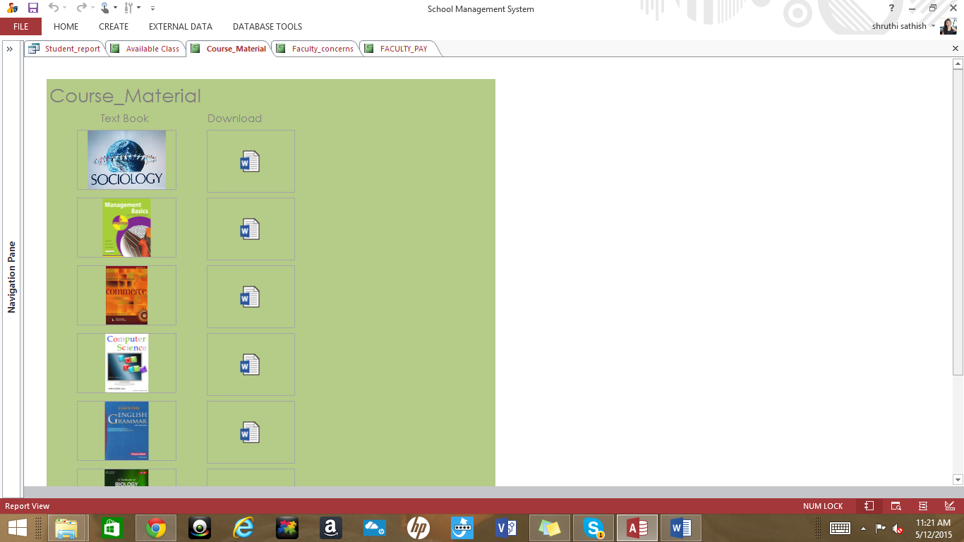

To show all concerns from faculties to the admin

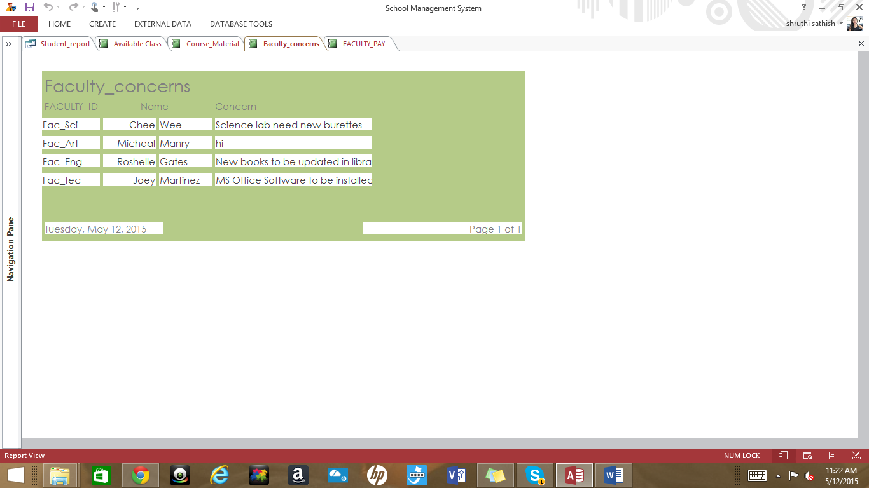

To show all available class rooms to faculty and allow them to book

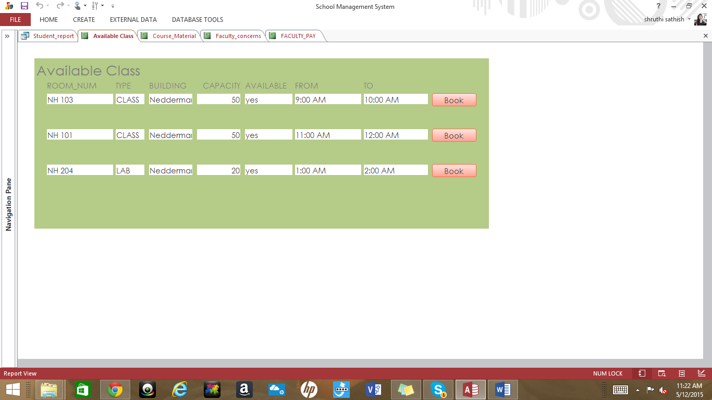

A report page to choose between student and faculty

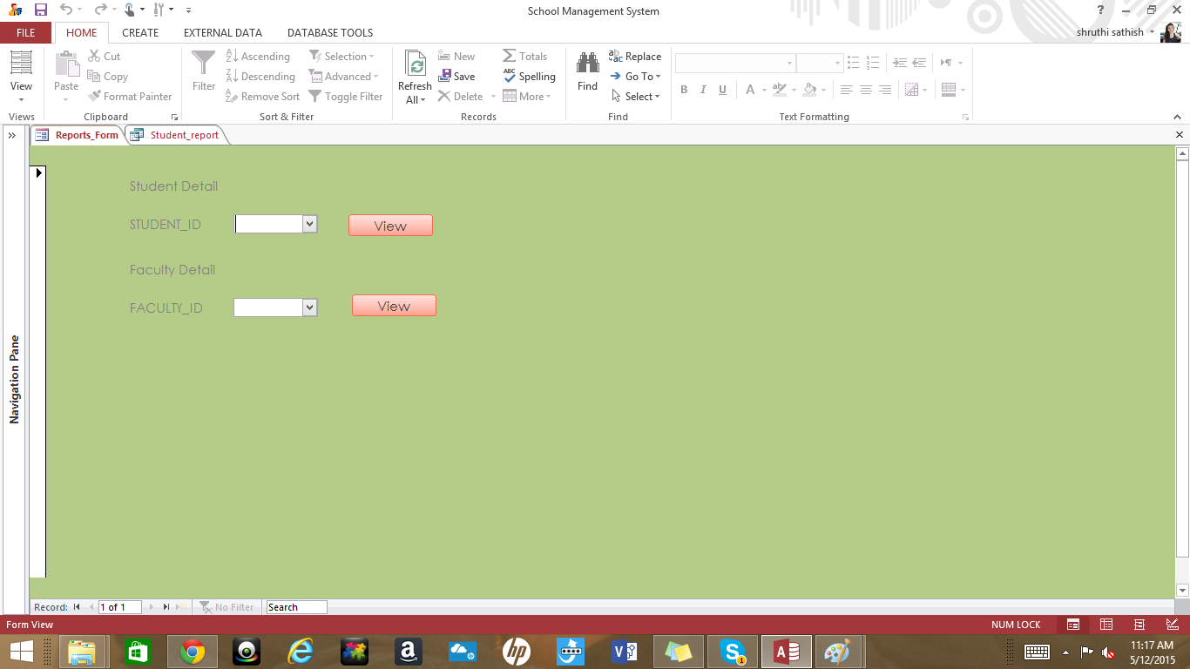

Student report including personal, academic, fee related information

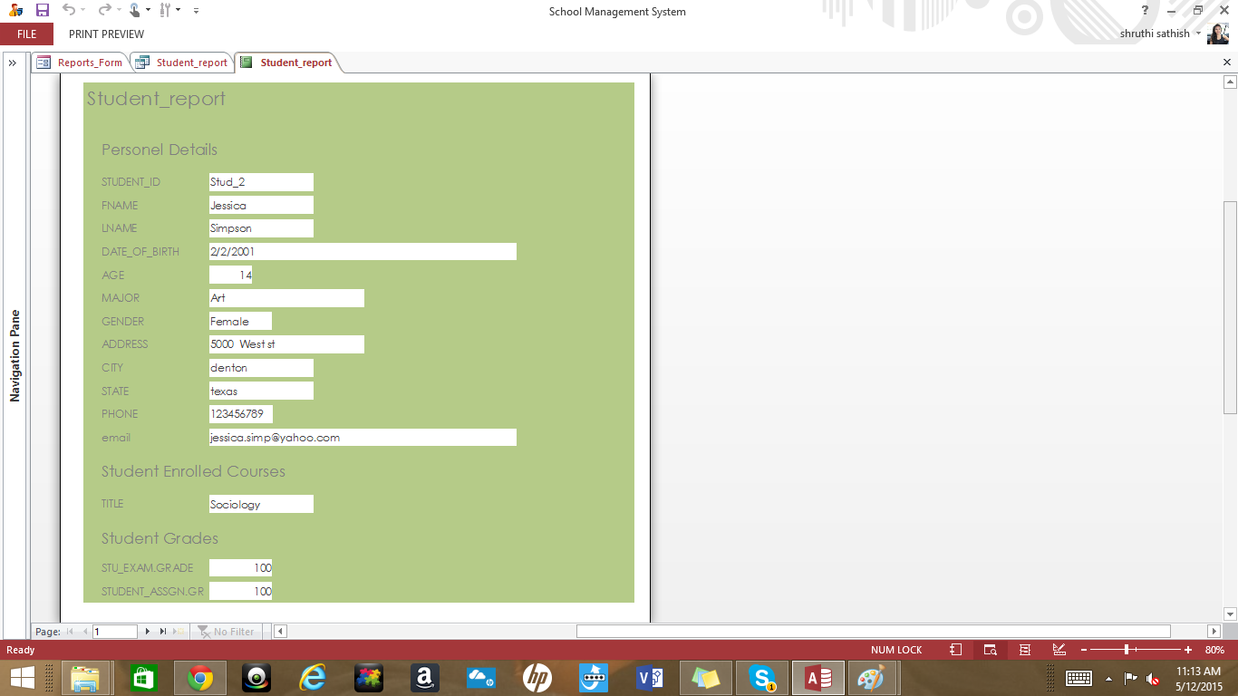

Report showing faculty personal, pay and course related information

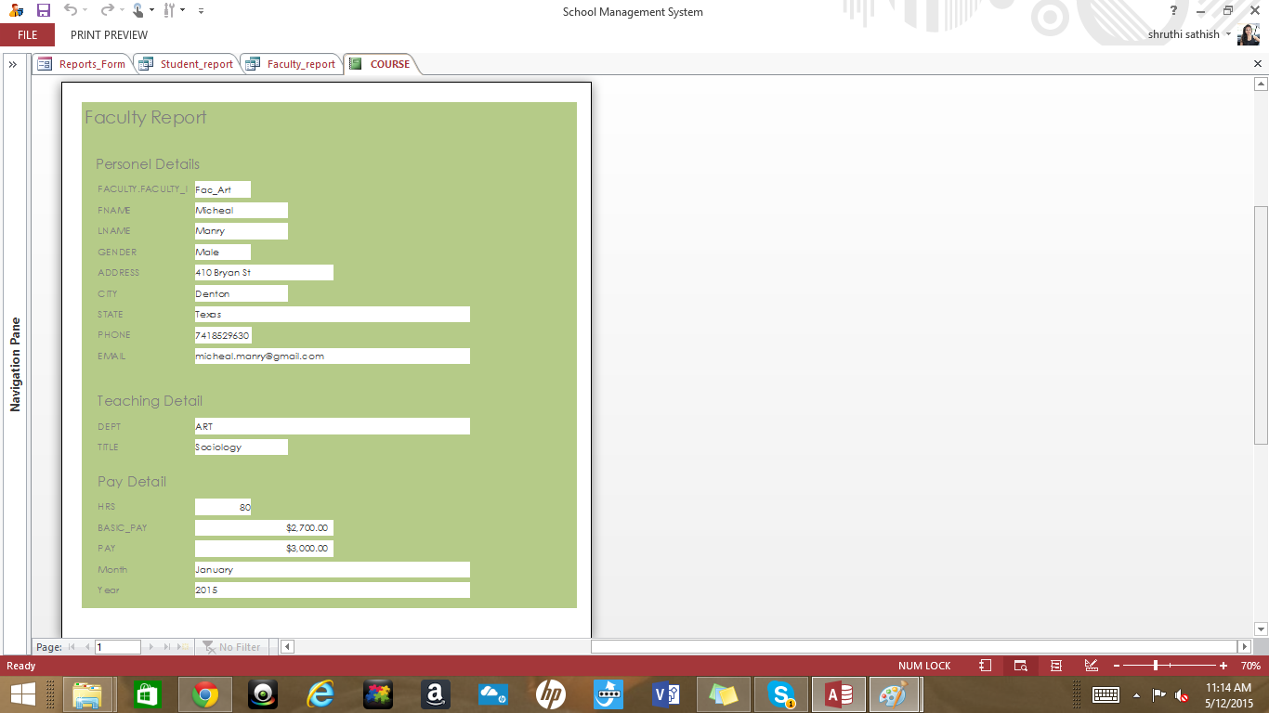

Application

The Login page for the application. Application allows three type of users ADMIN,FACULTY & STUDENT. User is expected to choose between how they want to login as and give appropriate username and password.

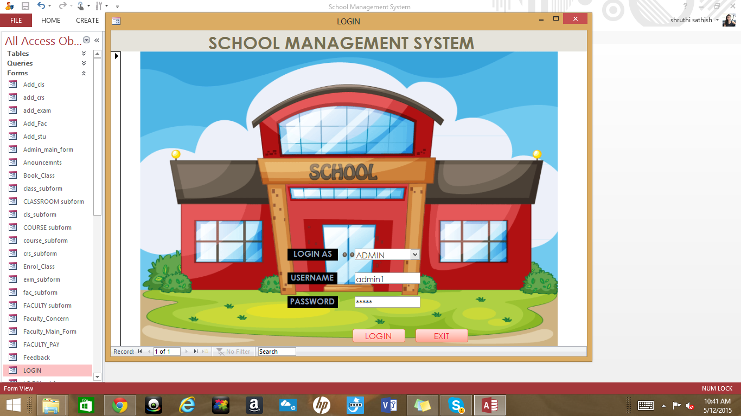

An error message showing invalid username/password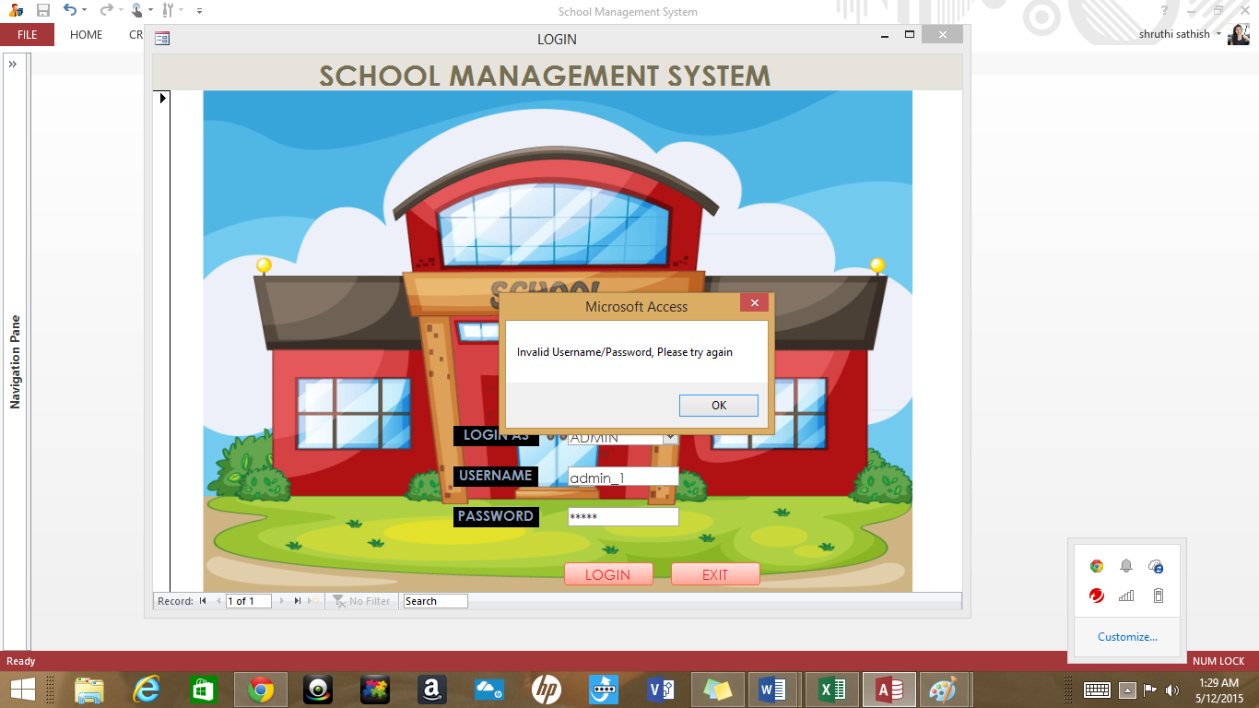

When user select to login as admin upon successful login he is redirected to admin main page.

Admin can Add/Update/Delete Student data and he can see the changes in the adjacent list.

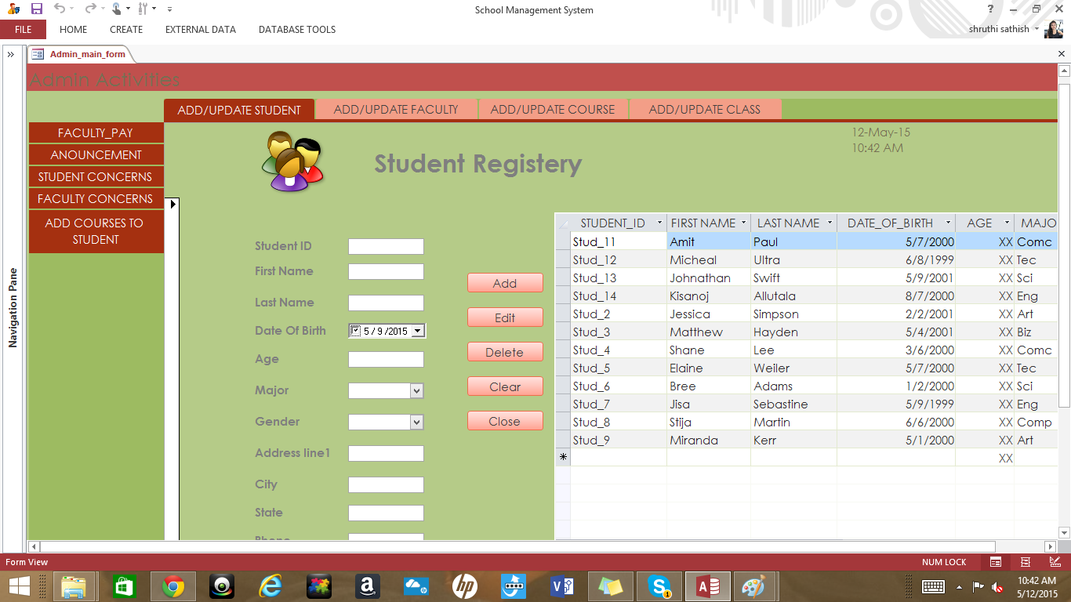

Admin can Add/Update/Delete Faculty data and he can see the changes in the adjacent list.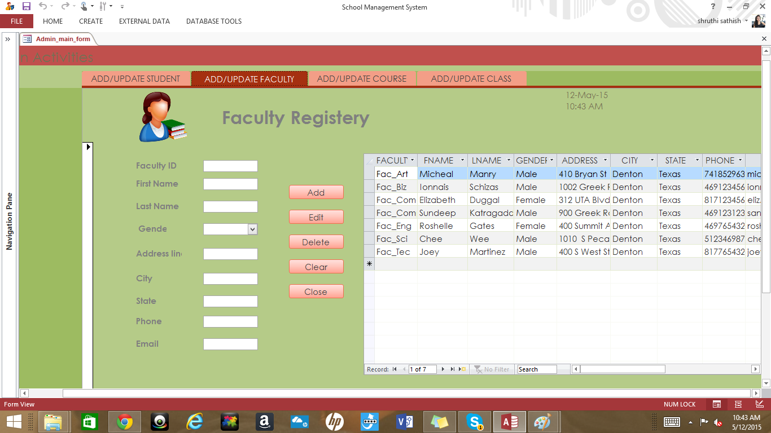

Admin can Add/Update/Delete Course data and he can see the changes in the adjacent list.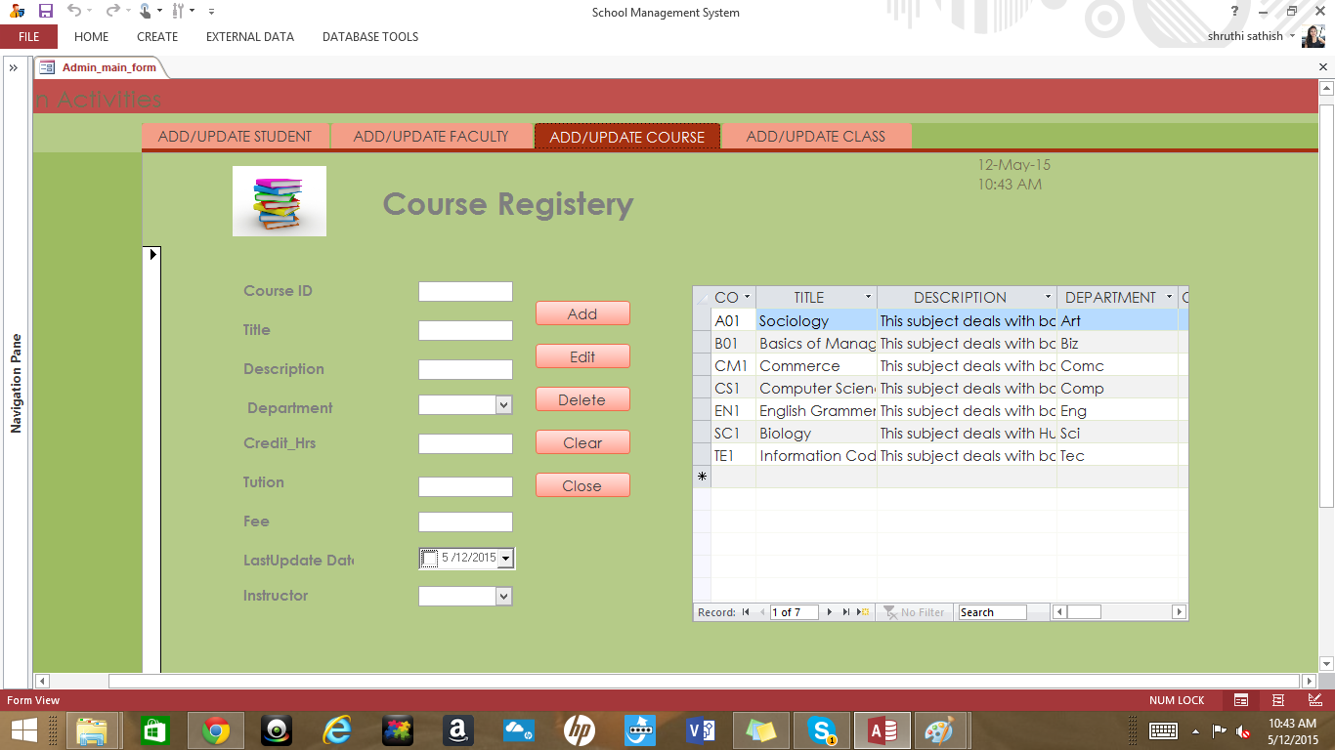

Admin can Add/Update/Delete Class room data and he can see the changes in the adjacent list.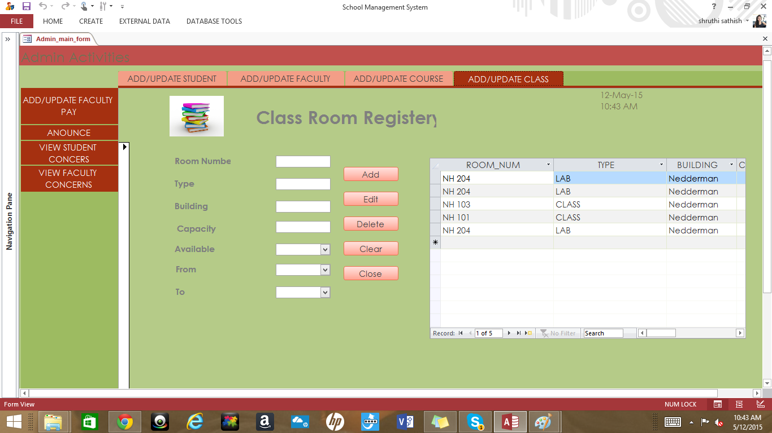

Admin can Add/Update/Delete Faculty pay data and he can see the changes in the list.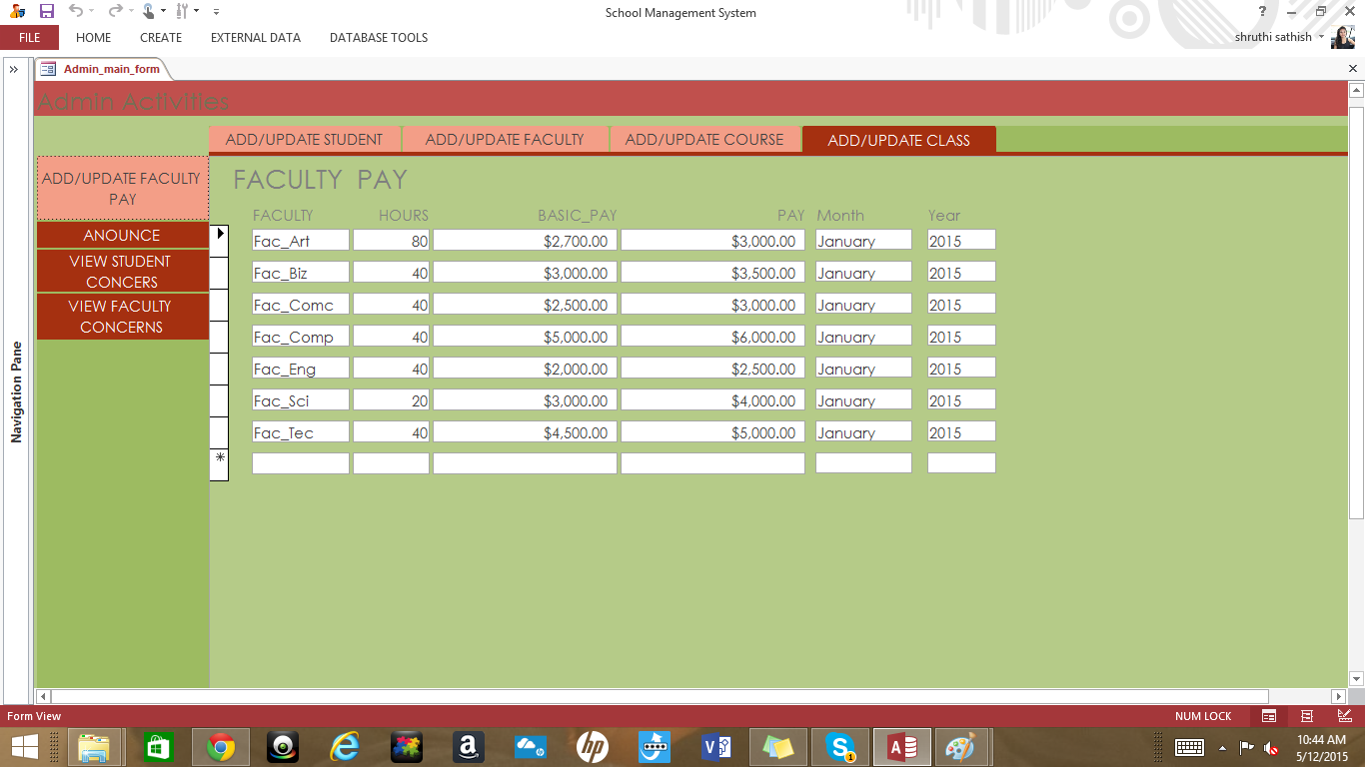

Admin can make announcements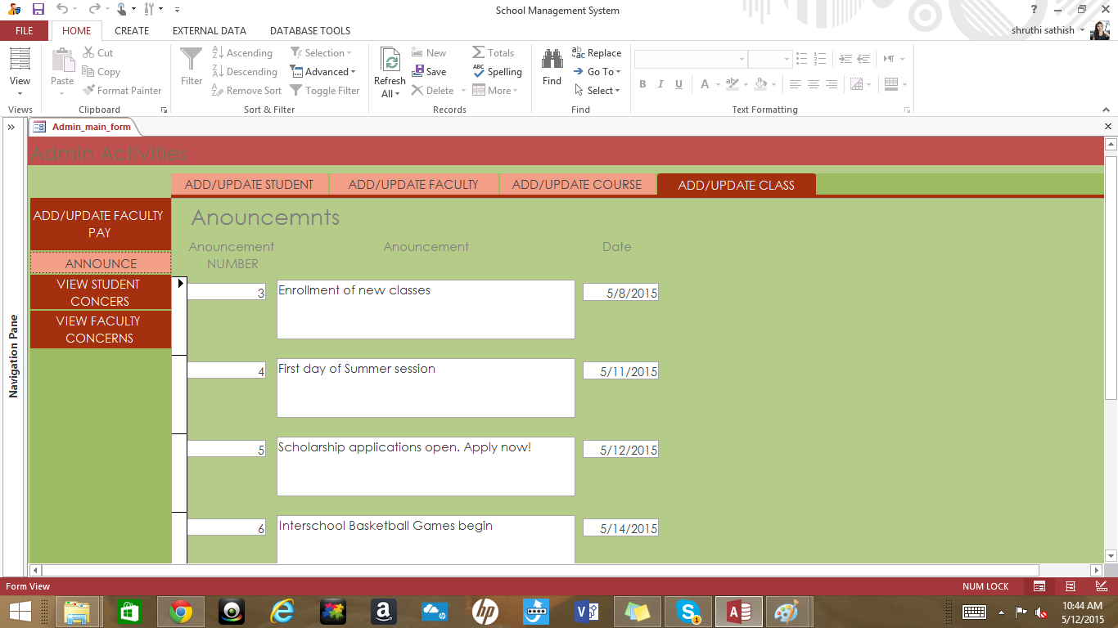

Admin can view Student concerns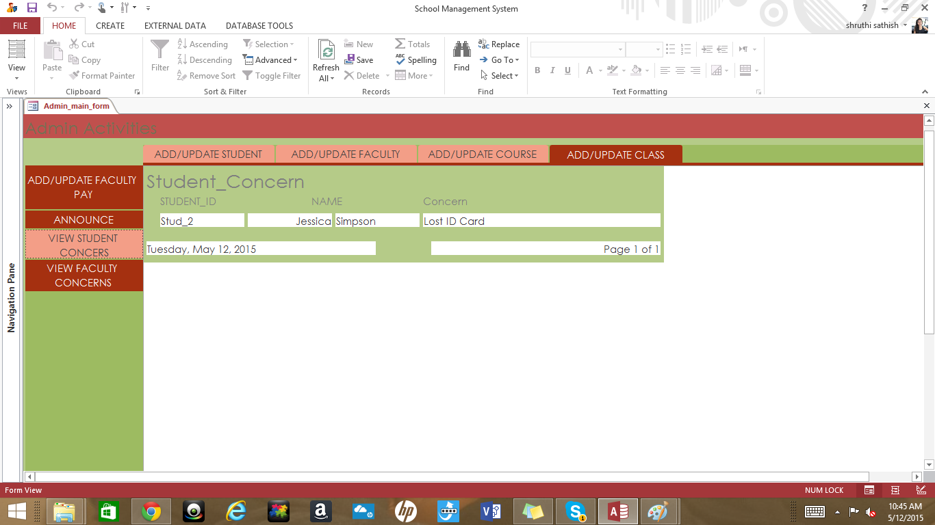

Admin can view faculty concerns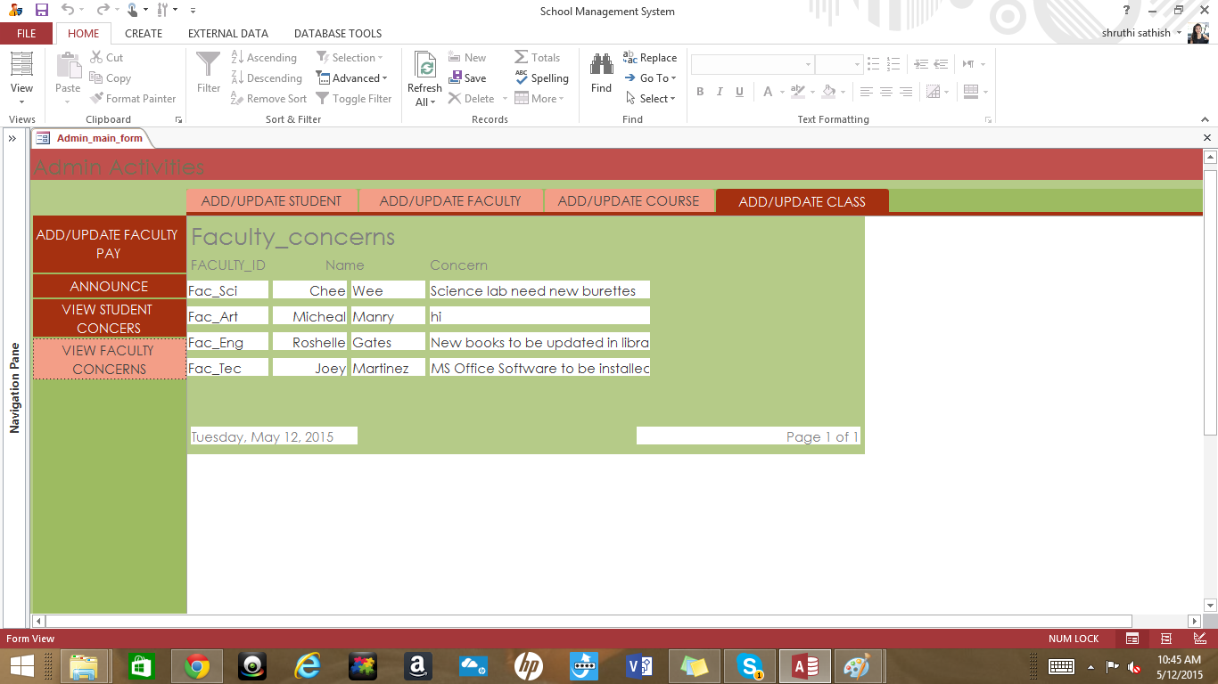

Faculty view list of students under her and take attendance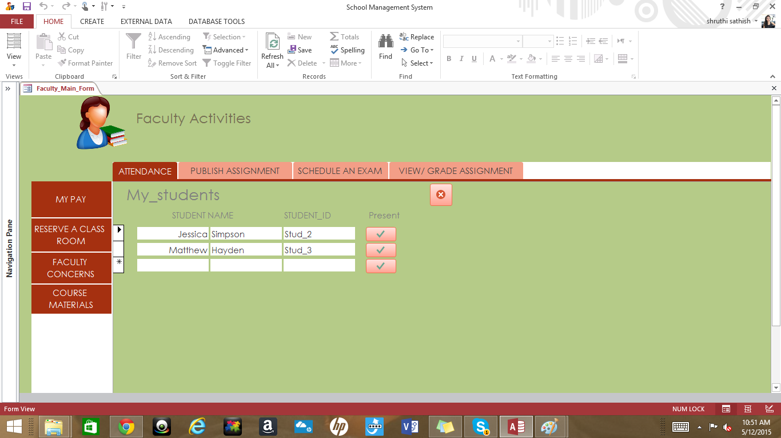

Faculty can publish assigments to student under them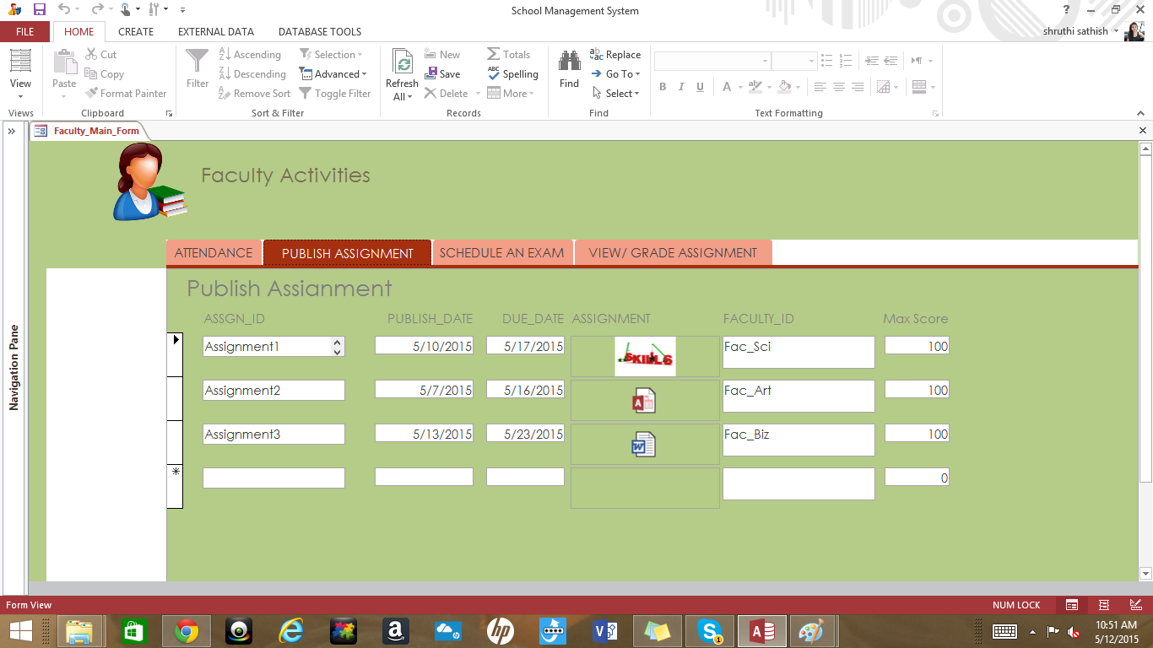

Faculty can schedule an examination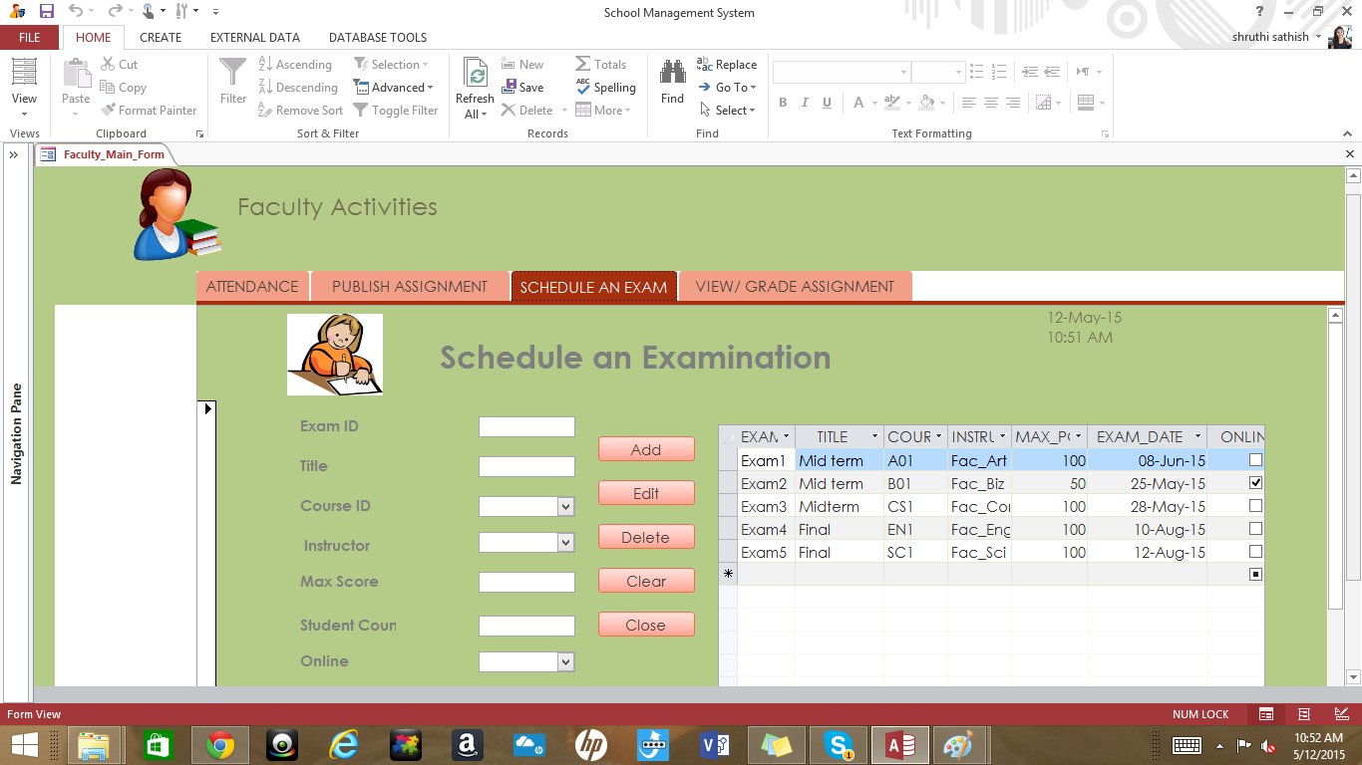

Faculty can view his/her pay detail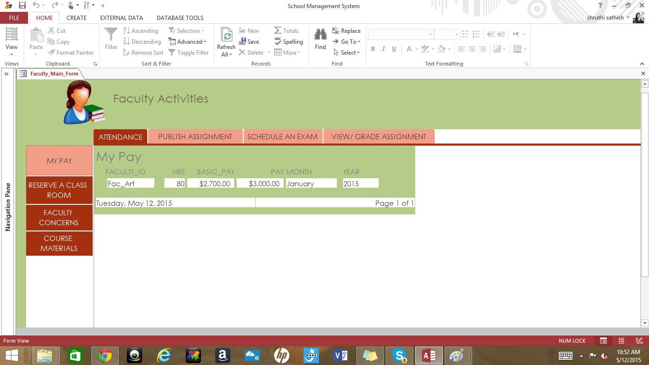

Faculty can reserve a classroom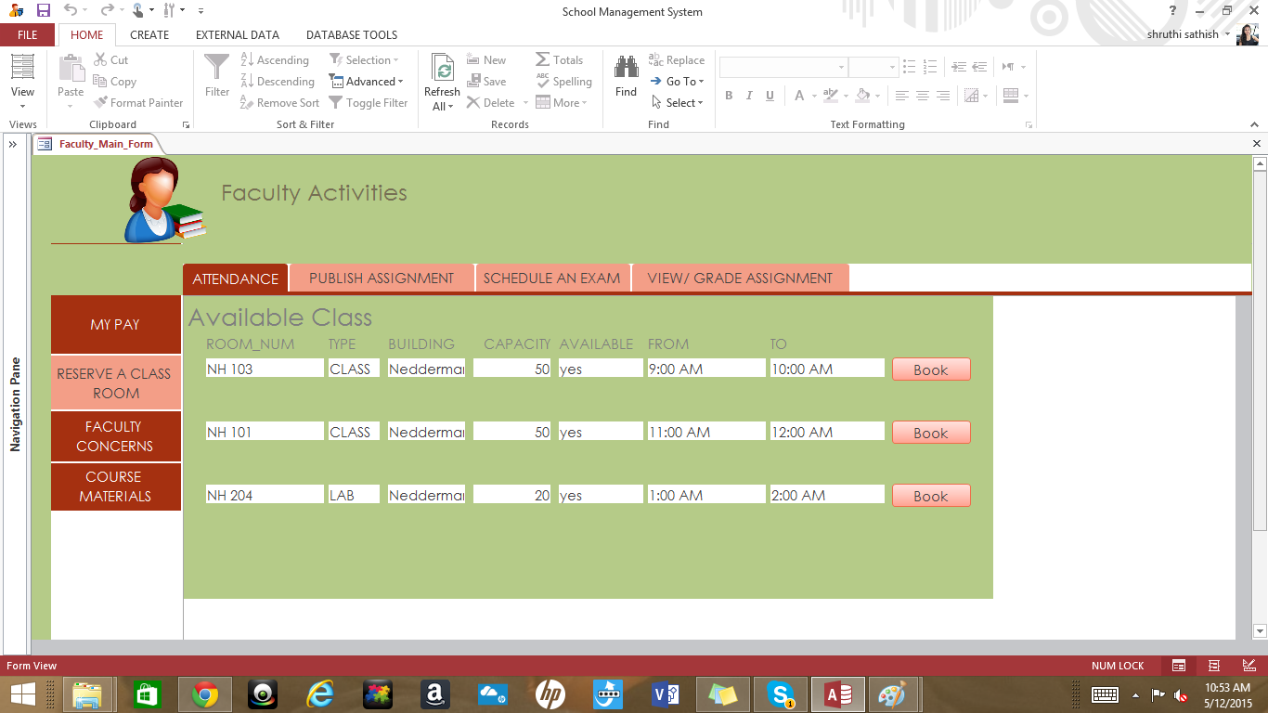

Faculty can submit their concerns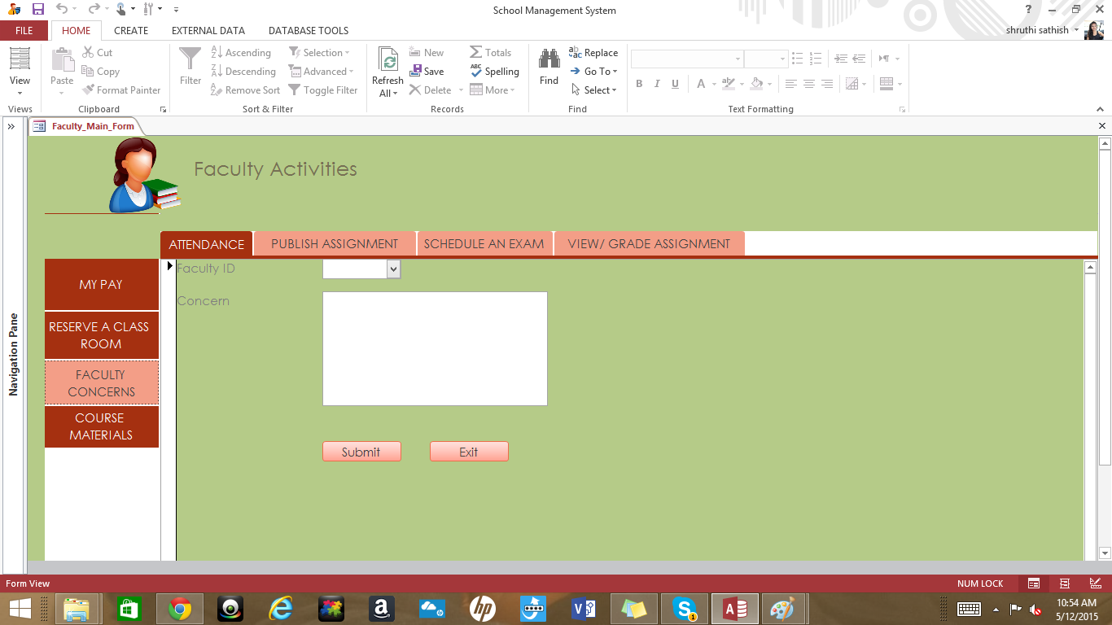

Faculty can view and download the course materials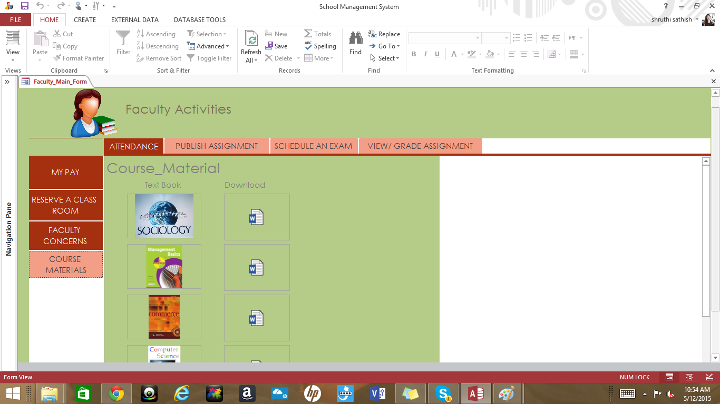

Student can view list of courses he is enrolled in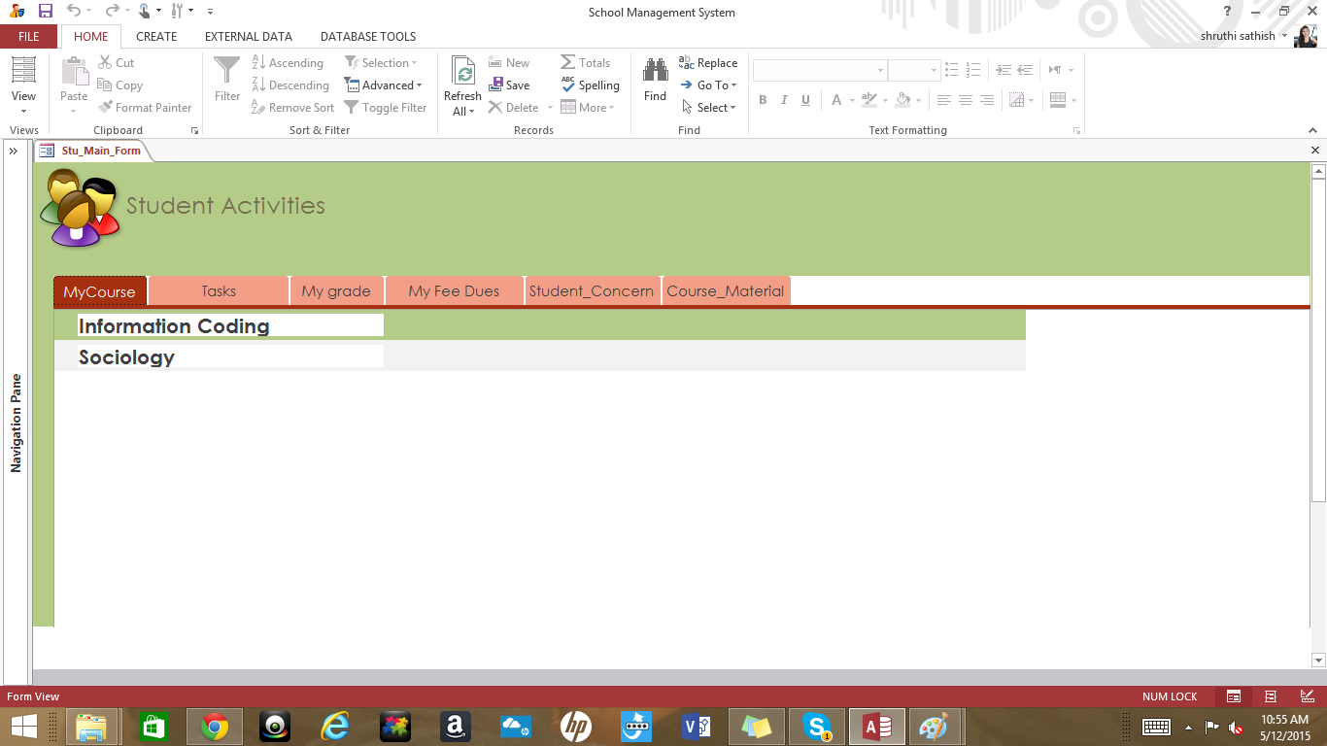

Student can view his/her task and upload the assignments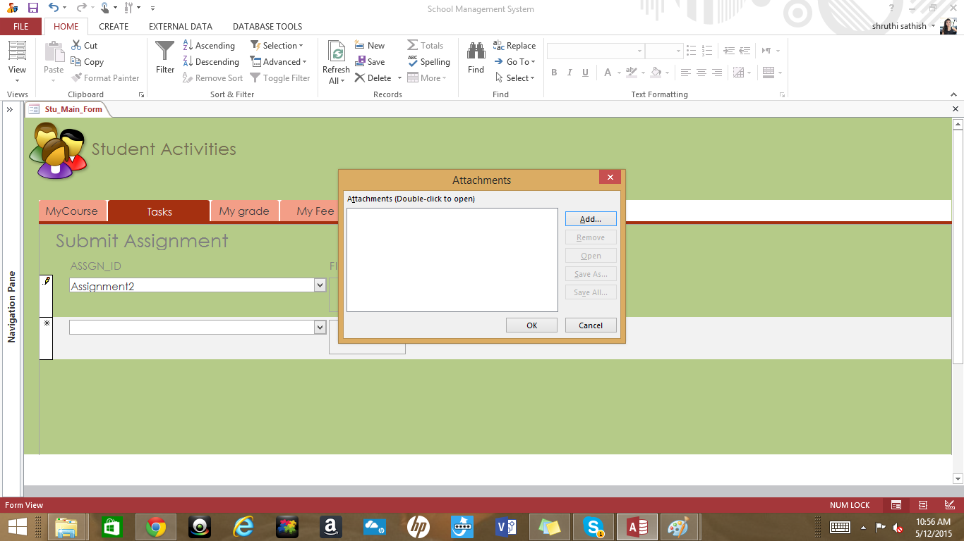

Student can view his/her grades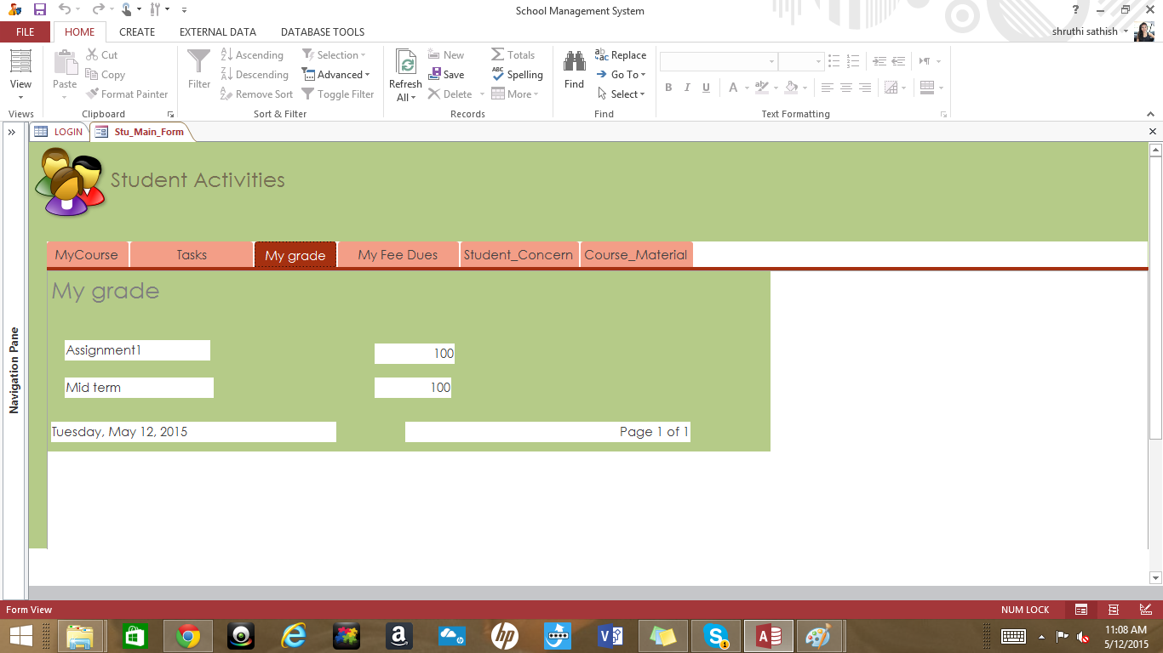

Student can view his/her fee dues and deadlines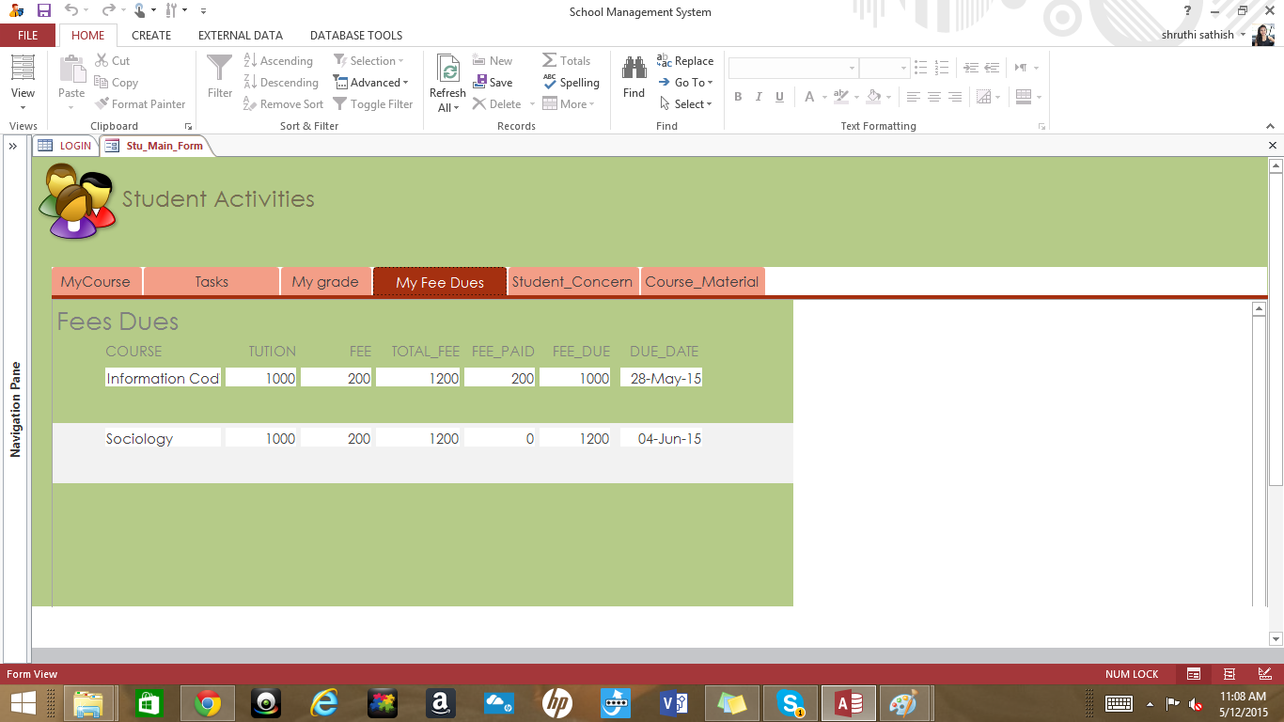

Student can submit their concerns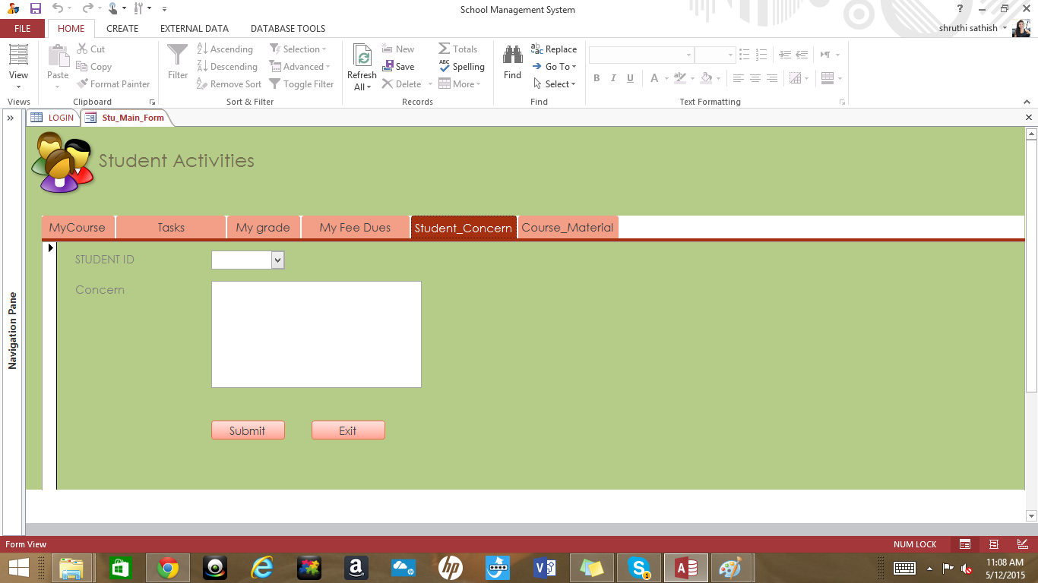

Student can view and download the course material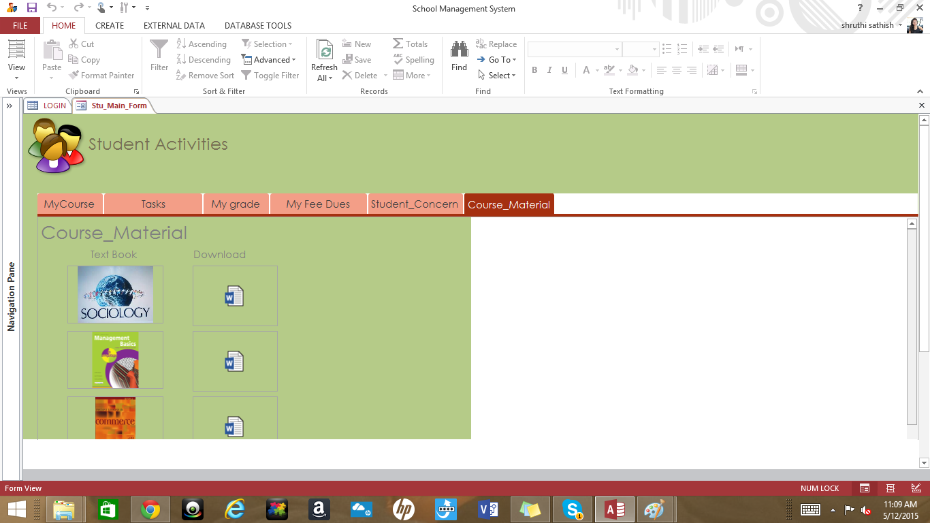

***Thank you***